**נספחים לש.ב. – מתמרים   
גיל אביר קבלרו / 201549912**

|  |  |  |  |  |  |  |
| --- | --- | --- | --- | --- | --- | --- |
| מספר נבדק | מדידה 1 | מדידה 2 | תוחלת נבדק | ס.ת נבדק | תוחלת כל המדגם |  |
| 1 | 1.37 | 1.19 | 1.28 | 0.127279 | 1.5625 |  |
| 2 | 1.32 | 1.33 | 1.325 | 0.007071 | ס.ת של המדגם |  |
| 3 | 1.4 | 1.35 | 1.375 | 0.035355 | 0.249139545 |  |
| 4 | 1.25 | 1.36 | 1.305 | 0.077782 |  |  |
| 5 | 1.29 | 1.38 | 1.335 | 0.06364 |  |  |
| 6 | 1.37 | 1.38 | 1.375 | 0.007071 |  |  |
| 7 | 1.4 | 1.38 | 1.39 | 0.014142 |  |  |
| 8 | 1.38 | 1.4 | 1.39 | 0.014142 |  |  |
| 9 | 1.38 | 1.43 | 1.405 | 0.035355 |  |  |
| 10 | 1.51 | 1.43 | 1.47 | 0.056569 |  |  |
| 11 | 1.57 | 1.54 | 1.555 | 0.021213 |  |  |
| 12 | 1.6 | 1.59 | 1.595 | 0.007071 |  |  |
| 13 | 1.53 | 1.61 | 1.57 | 0.056569 |  |  |
| 14 | 1.61 | 1.61 | 1.61 | 0 |  |  |
| 15 | 1.68 | 1.62 | 1.65 | 0.042426 |  |  |
| 16 | 1.76 | 1.78 | 1.77 | 0.014142 |  |  |
| 17 | 1.82 | 1.8 | 1.81 | 0.014142 |  |  |
| 18 | 1.89 | 1.85 | 1.87 | 0.028284 |  |  |
| 19 | 2.1 | 1.94 | 2.02 | 0.113137 |  |  |
| 20 | 2.2 | 2.1 | 2.15 | 0.070711 |  |  |

שאלה 1

שאלה 3

א.

function [meanDiff,sdDiff,CR] = BlandAltman(var1,var2)

var1 = double(var1);

var2 = double(var2);

if (nargin~=2)

errordlg('Bad Input')

end

if (nargin==2)

means = mean([var1;var2]);

diffs = var1-var2;

meanDiff = mean(diffs);

meanDiffVec(1:length(means)) = meanDiff;

sdDiff = std(diffs);

CR = [meanDiff + 1.96 * sdDiff, meanDiff - 1.96 * sdDiff]; %%95% confidence range

linFit = polyfit(means,diffs,1); %%%work out the linear fit coefficients

plot(means,diffs,'o')

hold on

plot(means, ones(1,length(means)).*CR(1),'r-'); %%%plot the upper CR

plot(means, ones(1,length(means)).*CR(2),'r-'); %%%plot the lower CR

plot(means,zeros(1,length(means)),'k'); %%%plot zero

plot(means, means.*linFit(1)+linFit(2),'y--'); %%%plot the linear fit

plot(means,meanDiffVec,'b');

title('Bland-Altman Plot')

errordlg('the vectors are independent statistically (Correlation in yellow) ')

end

ב.

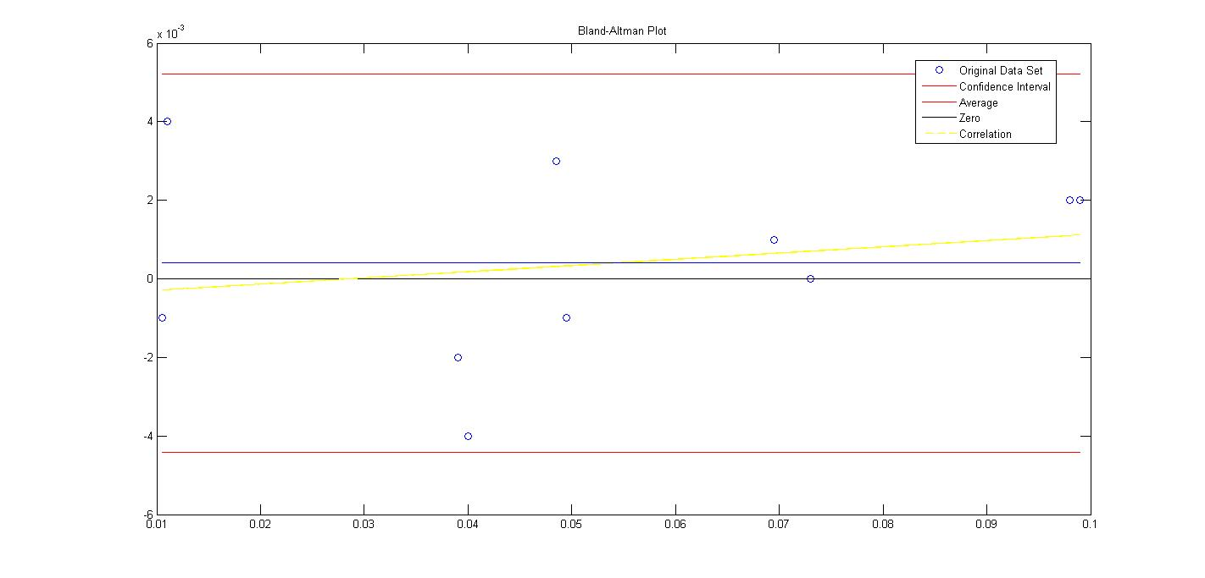

ג

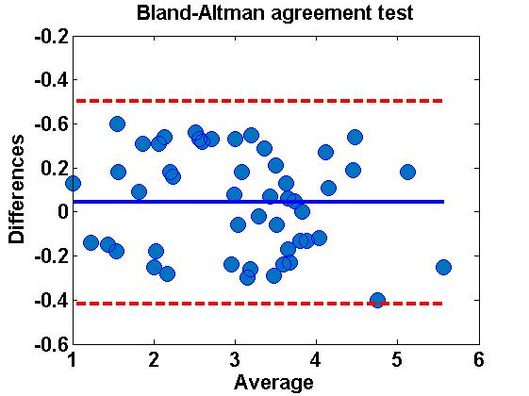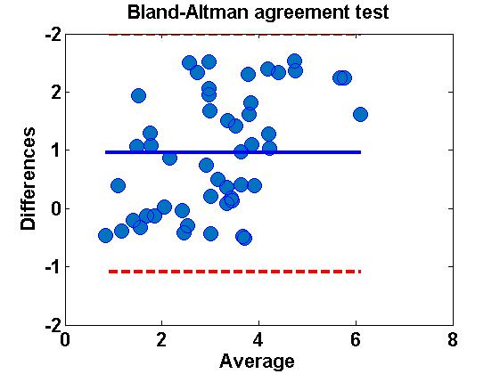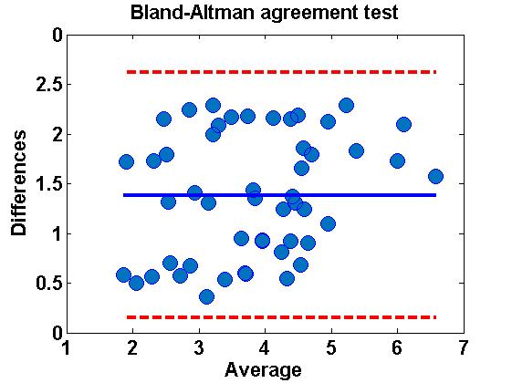

שאלה 4

גרף:

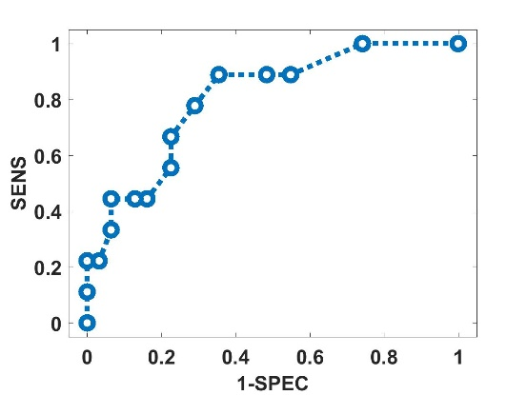

קוד:

golden=[0 0 0 0 0 0 0 0 0 0 0 1 0 0 0 0 0 0 0 0 0 0 1 0 0 1 0 1 0 1 0 0 0 0 1 0 1 0 1 1] ;

PSA_Levels=[0.42 0.43 0.44 0.46 0.47 0.47 0.56 0.62 0.64 0.65 0.70 0.71 0.82 0.89 0.89 1.13 1.21 1.27 1.38 1.52 1.57 1.68 1.81 1.82 1.94 1.94 2.03 2.29 2.64 2.64 2.77 2.96 3.24 3.46 3.81 4.16 4.27 4.78 5.52 5.70];

Threshold=0:(6-0)/(20-1):6;

sens=zeros(1,length(Threshold));

Pf = zeros(1,length(Threshold));

for j=1:length(Threshold)

TP =0; FT =0; FN =0; TN =0;

for i=1:40

if PSA_Levels(i)>=Threshold(j)

for N=i:40

if golden (N)==1

TP= TP+1;

else

FT= FT+1;

end

end

for N=1:i-1

if golden (N)==1

FN= FN+1;

else

TN = TN +1;

end

end

break

end

end

if PSA_Levels(i)<Threshold(j)

FN=sum(golden==1);

TN=sum(golden==0);

end

sum_all(j)=TP+TN+FT+FN; % checking that 4 groups equal 40 for each threshold;

sens(j)= TP/(TP+FN);

Pf(j)=1-(TN/(TN+ FT));

X = [0,1;Pf(j),sens(j)];

distance(j) = pdist(X,'euclidean');

end

ind=find(distance==min(distance));

optimal_threshold=Threshold(ind);

optimal_sens=sens(ind);

potimal_pf=Pf(ind);

plot(Pf,sens,'MarkerFaceColor',[1 1 1],'MarkerSize',10,'Marker','o','LineWidth',4,'LineStyle',':');

set(gca,'FontWeight','bold','FontSize',16);

xlabel('1-SPEC','FontWeight','bold','FontSize',16);

ylabel('SENS','FontWeight','bold','FontSize',16);

xlim([-0.05 1.05]);

ylim([-0.05 1.05]);